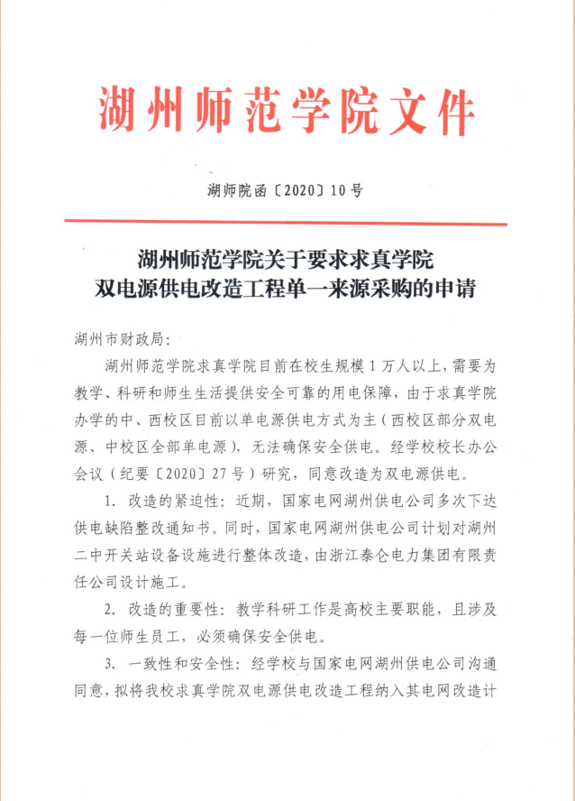

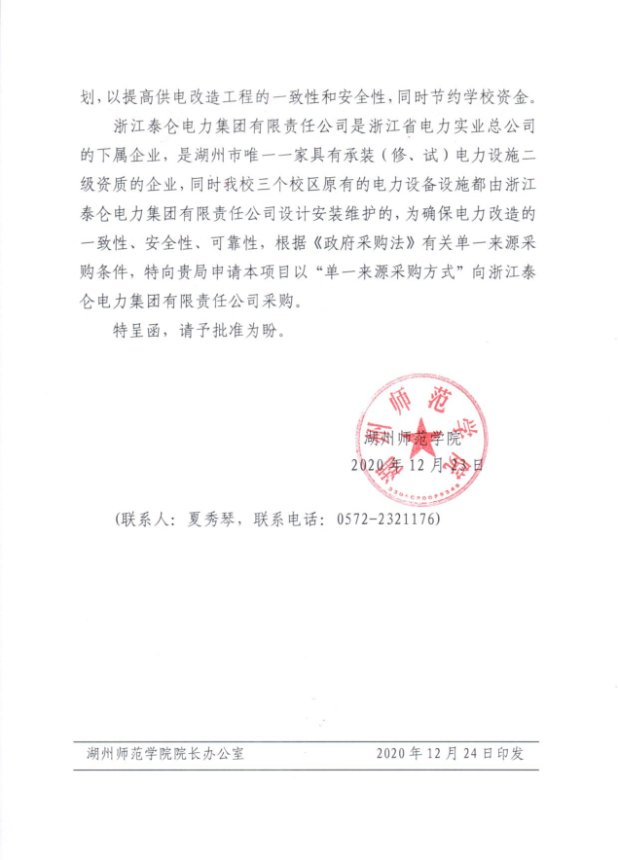

https://zfcg.czt.zj.gov.cn/innerUsed_noticeDetails/index.html?noticeId=7563597
